Outdoor Education Culminating Activity
Outline: Students not attending the camping culminating will complete two culminating activities. Please follow the instructions outlined below to aid you in your work.
Assignment One: IDC30 – Scrapbook.
Instructions: Throughout the course of the semester, students have been creating blogs outlining events and activities we have focused on. This assignment is designed to have you revisit and reorganize the blogs you have already written as a means to reflect on the course as a whole. Below are the key components of the scrapbook assignment. Please read through each step carefully in order to produce the required elements.
Step One – Copy your blogs to a doc.
Step Two – add visual interest to each of your blogs (colour, photos, fonts)
Step Three – create an introduction (Preface) for your scrapbook. Introductions should include information about the course, the blogs, and the assignment.
Step Four – Create a cover page for your scrapbook.
Step Five – Write a one page reflection of the course and your participation in it.
Step Six – Create a Table of Contents.
Reminder: Scrapbooks are meant to be visually appealing, filled with colour, texture, photos, etc. Do not simply submit black and white printed copies of your blogs (you are already receiving grades for the content in your blogs).
Due Date: Friday, June 13, 2014 @ 3:00 p.m.

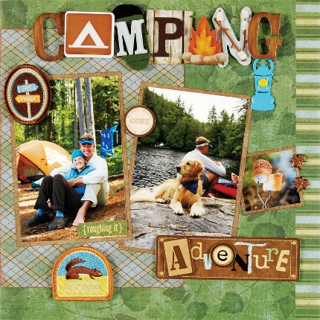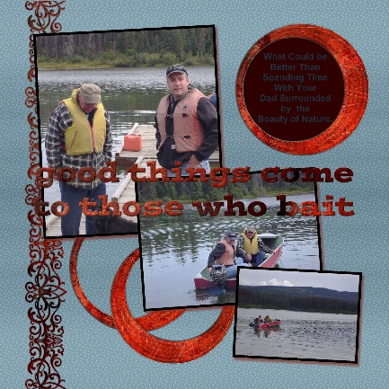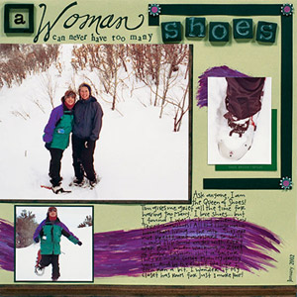

Scrapbook Rubric
Category | 4 | 3 | 2 | 1
Appearance of the Project | The project's appearance is professional and polished without distractive elements. Uses the required elements of the project to efficiently show the topic. | The project's appearance is quite professional and polished few distractive elements. White space is efficiently used. Contains all the requirements of the project. | The project's appearance is somewhat poor. Some distractive elements. Missing some of the requirements of the project. | The project's appearance is quite poor. Many distractive elements. Does not include the proper requirements for the project
Content Facts | The project content is exemplary and suggests the student has discovered the important ideas of his/her topic. | The project content is good and suggests the student has discovered most of the important facts of his/her topic. | The project content is fair/poor and suggests the student has not discovered most of the important facts. | The project content poor and suggests the student has not done sufficient research.
Style & Organization | Display is interesting and attractive. Materials are complete and organized to present the ideas well. | Display is interesting and attractive. Materials are complete and well organized. Presentation has sequence and plan evident. | Some parts of the display are interesting. Some materials are complete but lack organization. Presentation has some sequence and plan evident. | Display is uninteresting, not tidy. Materials are incomplete and not organized. Presentation has no sequence or plan evident.
Creativity & Appearance | Project is excellently presented reflecting creativity and a lot of thought. | Good creative effort. Project is neat and shows evidence of time spent on it. | Some attempt made to add color and originality. Project is neat, but appears to be rushed. | Little attempt to add color or originality. Project has sloppy appearance. Rushed to complete.
Knowledge | Scrapbook demonstrates a thorough knowledge of the subject investigated | The scrapbook demonstrates good knowledge of the subject investigated | The scrapbook demonstrates some knowledge of the subject investigated. | The scrapbook demonstrates very little knowledge of the subject investigated.
Outdoor Education Culminating Activity
Outline: Students not attending the camping culminating will complete two culminating activities. Please follow the instructions outlined below to aid you in your work.
Assignment Two: PAD3O – Fireside Promotional Product.
Instructions: Throughout the course of the semester, students have participated in many different events and activities. This assignment is designed to have you reflect on the course work and create a promotional piece outlining what the RMSS Fireside Outdoor Education Program is all about. Below are the key components of the promotional product assignment. Please read through each step carefully in order to produce the required elements.
Step One – Select the type of promotion you wish to create from the following list:
- Promotional piece/Brochure
- Webpage
- Commercial/Video
- Newspaper/Magazine
Step Two – create the written/oral component (minimum of 350 words) – this should outline the units of study from this semester.
Step Three – add visual interest to your product (colour, photos, fonts)
Step Four – include a minimum of three quotes from students in the program.
Step Five – Spell and Grammar check your work before submission.
Reminder: These products are meant to be visually appealing, filled with information, colour, photos, etc. Do not simply submit a black and white printed copy of your assignment.
Due Date: Friday, June 13, 2014 @ 3:00 p.m.
Promotional Piece Rubric
CATEGORY | 4 | 3 | 2 | 1
Format | The promotional piece has exceptionally attractive formatting and well-organized information. | The promotional piece has attractive formatting and well-organized information. | The promotional piece has well-organized information. | The promotional piece's formatting and organization of material are confusing to the reader.
Information | Contains information from all units of study | Contained all but one of the requirements. | Missed two or more of the requirements. | Missed three or more of the requirements.
Graphics | The graphics go well with the text and there is a good mix of text and graphics. | The graphics go well with the text, but there are so many that they distract from the text. | The graphics go well with the text, there are too few and the brochure seems “text-heavy”. | The graphics do not go with the accompanying text or appear to be randomly chosen.
Resources | All the resources used for the promotional piece are cited. | Three resources used for the promotional piece are cited. | Two resources used for the promotional piece are cited. | Only one resource is cited or resources are cited incorrectly.
Editing | No spelling errors or grammar errors | No more than 1 spelling error or grammar error | No more than 3 spelling errors and/or grammar errors | Several spelling and/or grammar errors.

